**WEB TECHNOLOGIES**

**PRACTICAL NOTE BOOK**

**SUBMITTED TO : GURU NANAK DEV ENGINEERING COLLEGE ( PTU AFFILIATED INSTITUTE) FOR THE COURSE INFORMATION TECHNOLOGY**

**{ BATCH 2019-2023 }**

**SUBMITTED TO:Mrs. HANIT SOHAL { DEPARTMENT OF INFORMATION TECHNOLOGY }**

**SUBMITTED BY: MUKUL**

**{ IT 4 TH SEMESTER 1905364/1921066}**

**EXPERIMENT 1**

1.Create a simple web pages by writing HTML using a simple text editor, notepad. Demonstrate the following components of the web page : page title and headings paragraph and inline images.

<!DOCTYPE html>

<html>

<head>

<title>First Practical</title>

</style>

<body style="background-color: #050504">

<h1 style="color: #ffffff;text-align: center; font-size: 50px; font-family:

Helvetica;"><b>This is our first practical.</b></h1>

<h2 style="color: #ffffff;text-align: center; font-size: 50px; font-family:

Helvetica;">CARS WALPAPERS WEBPAGE.</h2>

<img

src="https://external-content.duckduckgo.com/iu/?u=https%3A%2F%2Fts

e1.mm.bing.net%2Fth%3Fid%3DOIP.Cs4fei7P2Qj4OZ3ZsnFcRgHaEK%26pi

d%3DApi%26h%3D160&f=1" alt="car walpapers" width="150"

height="150">

<img

src="https://external-content.duckduckgo.com/iu/?u=https%3A%2F%2Fts

e1.mm.bing.net%2Fth%3Fid%3DOIP.a-vvsNtjZLD7ejszkZyMHwHaEo%26pi

d%3DApi&f=1 width150" height="150">

<img

src="https://external-content.duckduckgo.com/iu/?u=https%3A%2F%2Fts

e1.mm.bing.net%2Fth%3Fid%3DOIP.E4JAqNh5GN-IPDQAa9YLswHaE8%26

pid%3DApi&f=1" width="150" height="150">

<img

src="https://external-content.duckduckgo.com/iu/?u=https%3A%2F%2Fts

e2.mm.bing.net%2Fth%3Fid%3DOIP.e5gQH3miiJn6reT5tvxcwQHaEZ%26pi

d%3DApi&f=1" width="150" height="150">

<img

src="https://external-content.duckduckgo.com/iu/?u=https%3A%2F%2Fts

e3.mm.bing.net%2Fth%3Fid%3DOIP.-QaqZsptAYfnJgu23aUUggHaEK%26pi

d%3DApi&f=1" width="150" height="150">

<img

src="https://external-content.duckduckgo.com/iu/?u=https%3A%2F%2Fts

e4.mm.bing.net%2Fth%3Fid%3DOIP.G2CIyoH7Snec_PsF1Iu_0gHaEo%26pi

d%3DApi&f=1" width="150" height="150">

<p style="color: #ffffff;">In this Webpage you can access different

websites in which you can download Car Walpapers For Free. We Provide

The Links to These Websites Given Below:</p>

<a href="https://wallpapercave.com/w/ojycKEO" style="color:

#ffffff;">WEBSITE 1</a>

<a href="https://wallpaper-mania.com/post/wallpaper-id-77700072335/"

style="color: #ffffff; padding-left: 100px;">WEBSITE 2</a>

<a href="https://github.com/davinder22133" style="margin-left: 200px;

color: #ffffff;">About Us</a>

</body>

</head>

</html>

**OUTPUT:**

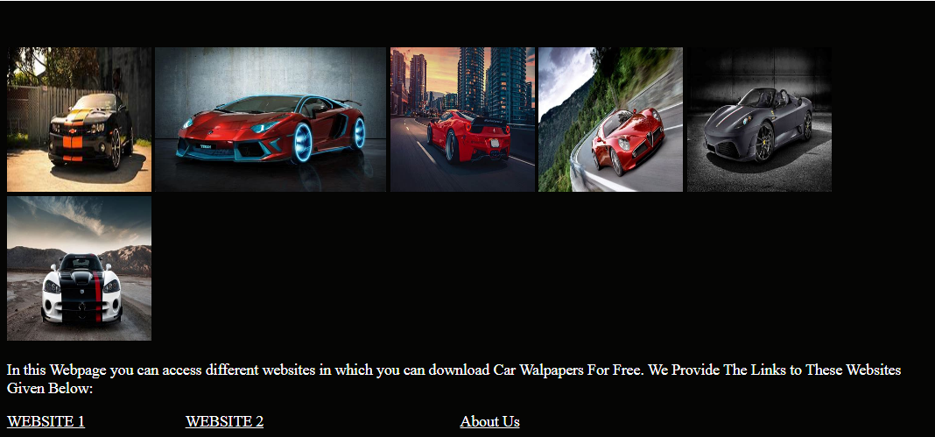

**EXPERIMENT-2**

2. Demonstrate the use of links, lints, and tables in html. You should be able to link separate pagesand create named links within a document, using them to build a “table of contents”.

<!DOCTYPE html>

<html>

<head>

<style>

table {

font-family: arial;

border-collapse: collapse;

width: 100%;

}

td, th {

border: 1px solid #020202;

text-align: left;

padding: 10px;

}

</style>

</head>

<body style="background-color: lightblue;">

<table>

<tr>

<th>CARS NAME</th>

<th>PRICE LIST</th>

<th>SHOWROOM ADDRESS</th>

</tr>

<tr>

<th> DODGE </th>

<th>Starting 37.90 Lakhs</th>

<th>New Haibowal, Ludhiana.</th>

</tr>

<tr>

<th>AUDI</th>

<th> Starting 20.6 Lakhs</th>

<th> Model Town, Ludhiana.</th>

</tr>

<tr>

<th>TOYTA</th>

<th>Starting 15.8 Lakhs</th>

<th>Sanhewal, Ludhiana.</th>

</tr>

</table>

<img

src="https://cars.usnews.com/static/images/Auto/izmo/i159614376/2021_dodge_challenger_angularfront.jpg" width="150"

height="150" style="padding-left: 180px;">

<img

src="https://audimediacenter-a.akamaihd.net/system/production/media/87623/images/ab698ab934ad7ee485d260ff1d2569be289629dc/A1915496_x500.jpg?1582587184" width="150"

height="150">

<img

src="https://cdni.autocarindia.com/Utils/ImageResizer.ashx?n=http%3A%2F%2Fcms.haymarketindia.net%2Fmodel%2Fuploads%2Fmodelimages%2Ftoyota-fortuner-110120211829.jpg&h=300&w=450&q=100" width="150"

height="150"><br>

<a href="https://www.dodge.com/">Link To DODGE

Car Website.</a><br>

<a href="https://www.audiusa.com/content/dam/audiusa/Documents/Audi-Connect-Setup-Guide.pdf">Link To

AUDI Car Website.</a><br>

<a href="https://www.toyotabharat.com/">Link To TOYTA Car

Website.</a>

</body>

</html>

OUTPUT:

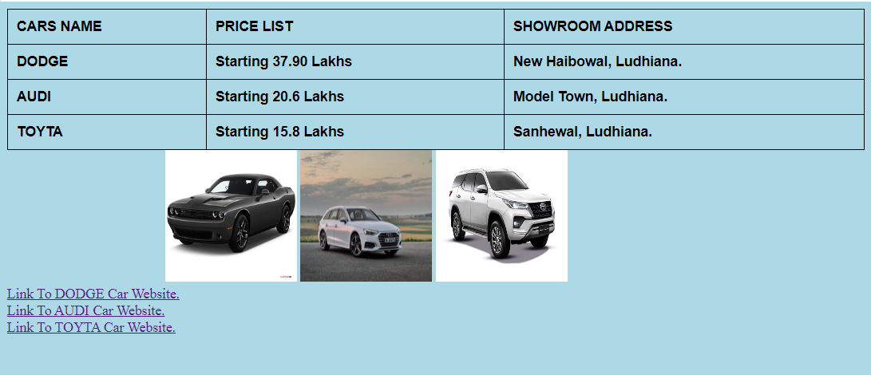

**EXPERIMENT-3**

3.Create a simple forms in HTML and demonstrate the use of various form elements like input box, textarea, submit and radio buttons etc.

<!DOCTYPE html>

<html>

<head>

<meta http-equiv="content-type" content="text/html" charset="UTF-8"/>

<title>our books collection<title>

</head>

<body>

<form action="processcomment.php" method"POST">

<label for="uname">Username:</label>

<input type="text" name="username"><br>

<p>rate the book where 5 is best</p>

<input type="radio" value="1">1

<input type="radio" value"2">2

<input type="radio" value="3">3

<input type="radio" value="4">4

<input type="radio" value="5">5

<label for="comment" name="rating" value="comment">comment:</label>

<textarea name="comment" rows="20" cols="30"></textarea><br>

<input type="submit" name="submit" value="submit">

<button type="reset" value="reset">reset</button>

<br><br>

</form>

<form action="/index.html" method="GET">

<input type="home" value="home">

</form>

</body>

</html>

OUTPUT:

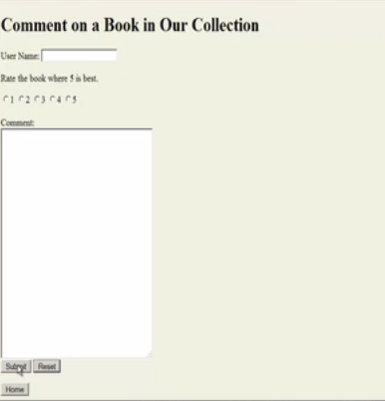

**EXPERIMENT 4**

4.Demonstrate the use of cascading style sheets(CSS) (inline, internal and external) to specify various aspects of style, such as colours and text fonts and sizes, in HTML document.

<!DOCTYPE html>

<html lang="en-us">

<head>

<link rel="stylesheet" type="text/css" href="css/fourthh.css" >

<title>Types Of CSS</title>

<style >

body{

background-color: #ff3d3d;

}

</style>

</head>

<body>

<h1 style="font-family: serif;">USING DIFFERENT FORMS OF CSS(Inline,Internal,External)</h1>

<p>I Am Davinder kumar (CRN 1921022,URN 1905321) Studied At GNDEC Ludhiana In BTech 4th

Sem IT.</p>

<a href="https://github.com/davinder22133" style="margin-left: 50px;color: #000000; font-size:

20px;">My Github Profile Link</a>

<h2>How I Learn My Web Technologies Languages (HTML and CSS)</h2>

<p>I Am Learn HTML and CSS course From Udemy Course.The Link To This Course Is Provided

Given Below. It Is A Paid Course. I Am Purchase On Sales Days On Udemy About Rs 455.

It Is A Best Course For Starting HTML and CSS.</p>

<a

href="https://www.udemy.com/course/design-and-develop-a-killer-website-with-html5-and-css3/"

style="color: #000000;margin-left: 50px; font-size: 20px;">Link to Udemy Course</a>

</body>

</html>

fourthh.css (External CSS file)

p{

background-color: #000000;

font-family: Times New Roman;

font-size: 20px;

color: #ffff;

}

**OUTPUT:**

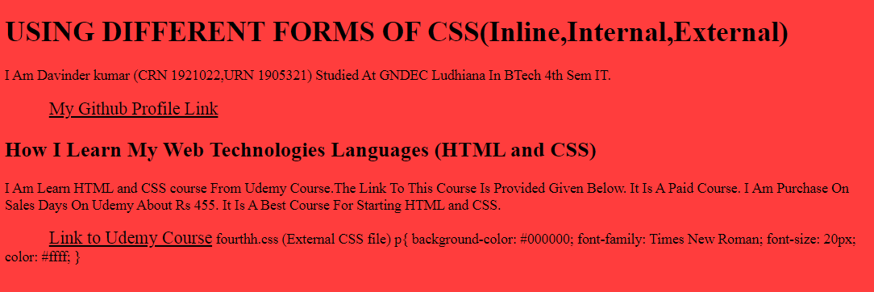

**EXPERIMENT 5**

5. Create of web pages using HTML5 & CSS3.

<!DOCTYPE html>

<html lang="en">

<head>

<meta charset="UTF-8">

<meta name="viewport" content="width=device-width, initial-scale=1.0">

<title>FITNESS</title>

<link rel="stylesheet" href="css/style.css">

<style>

body {

color: white;

/* css reset */

margin: 0px;

padding: 0px;

background: url('https://www.uvoider.com/blog/wp-content/uploads/2019/08/weights1.jpg');

background-position: center;

background-repeat: no-repeat;

background-size: cover;

height: 100%;

}

.left {

position: absolute;

left: 25px;

top: 20px;

display: inline-block;

/* border: 2px solid red; */

}

.left img {

width: 114px;

filter: invert(100%);

}

.left div {

text-align: center;

}

.mid {

/* border: 2px solid green; */

display: block;

width: 36%;

margin: 25px auto;

}

.right {

position: absolute;

right: 25px;

top: 30px;

display: inline-block;

/* border: 2px solid yellow; */

}

.navbar {

display: inline-block;

}

.navbar li {

display: inline-block;

font-size: 15px;

}

.navbar li a {

color: white;

text-decoration: none;

padding: 15px 16px;

}

.navbar li a:hover {

text-decoration: underline;

color: gray;

}

.btn {

margin: 0px 9px;

color: white;

background-color: black;

padding: 4px 12px;

border: 2px solid grey;

cursor: pointer;

}

.btn:hover {

background-color: rgb(97, 93, 93);

}

.container {

border: 2px solid orange;

border-radius: 15px;

margin: 143px 37px;

padding: 75px;

width: 33%;

}

.form_grp input {

text-align: center;

display: block;

width: 228px;

padding: 4px;

/* border: 3px solid blue; */

margin: 6px auto;

}

h1 {

text-align: center;

font-size: 35px;

font-style: italic;

}

.container button{

display: block;

width: 77px;

margin: auto;

}

</style>

</head>

<body>

<header class="header">

<div class="left">

<!-- left box for logo -->

<img src="https://i.pinimg.com/564x/0f/e0/05/0fe005679f54e54358f480c0ffe7aa34.jpg" alt="yooo">

<div>KALSI FITNESS</div>

</div>

<div class="mid">

<!-- mid box for navigation -->

<ul class="navbar">

<li><a href="#"> HOME</a></li>

<li><a href="#"> ABOUT US</a></li>

<li><a href="#"> CENTRE</a></li>

<li><a href="#"> CONTACT US</a></li>

</ul>

</div>

<div class="right">

<!-- right box for -->

<button class="btn">Call Us Now</button>

<button class="btn">Email Us</button>

</div>

</header>

<div class="container">

<h1>ARORA FITNESS</h1>

<form action="noaction.php">

<div class="form_grp">

<input type="text" name="" placeholder="ENTER YOUR NAME">

</div>

<div class="form_grp">

<input type="text" name="" placeholder="ENTER YOUR AGE">

</div>

<div class="form_grp">

<input type="text" name="" placeholder="ENTER YOUR GENDER">

</div>

<div class="form_grp">

<input type="text" name="" placeholder="ENTER YOUR LOCALITY">

</div>

<button class="btn">SUBMIT</button>

</form>

</div>

</body>

</html>

**OUTPUT:**



EXPERIMENT 6

6.Demonstrate the use of Bootstrap Framework.

**<!DOCTYPE html>**

**<html lang="en">**

**<head>**

**<meta charset="UTF-8" />**

**<meta http-equiv="X-UA-Compatible" content="IE=edge" />**

**<meta name="viewport" content="width=device-width, initial-scale=1.0" />**

**<title>Practical 6</title>**

**<link**

**rel="stylesheet"**

**href="https://cdn.jsdelivr.net/npm/bootstrap@4.6.0/dist/css/bootstrap.min.css"**

**integrity="sha384-B0vP5xmATw1+K9KRQjQERJvTumQW0nPEzvF6L/Z6nronJ3oUOFUFpCjEUQouq2+l"**

**crossorigin="anonymous"**

**/>**

**</head>**

**<body style="padding: 50px">**

**<nav class="navbar navbar-expand-lg navbar-dark bg-dark">**

**<a class="navbar-brand" href="#">Navbar</a>**

**<button**

**class="navbar-toggler"**

**type="button"**

**data-toggle="collapse"**

**data-target="#navbarTogglerDemo02"**

**aria-controls="navbarTogglerDemo02"**

**aria-expanded="false"**

**aria-label="Toggle navigation"**

**>**

**<span class="navbar-toggler-icon"></span>**

**</button>**

**<div class="collapse navbar-collapse" id="navbarTogglerDemo02">**

**<ul class="navbar-nav mr-auto mt-2 mt-lg-0">**

**<li class="nav-item active">**

**<a class="nav-link" href="#"**

**>Home <span class="sr-only">(current)</span></a**

**>**

**</li>**

**<li class="nav-item">**

**<a class="nav-link" href="#">Link</a>**

**</li>**

**<li class="nav-item">**

**<a**

**class="nav-link disabled"**

**href="#"**

**tabindex="-1"**

**aria-disabled="true"**

**>Disabled</a**

**>**

**</li>**

**</ul>**

**<form class="form-inline my-2 my-lg-0">**

**<input**

**class="form-control mr-sm-2"**

**type="search"**

**placeholder="Search"**

**/>**

**<button class="btn btn-outline-success my-2 my-sm-0" type="submit">**

**Search**

**</button>**

**</form>**

**</div>**

**</nav>**

**<br />**

**<div class="alert alert-success" role="alert">**

**<h4 class="alert-heading">Well done!</h4>**

**<p>**

**Aww yeah, you successfully read this important alert message. This**

**example text is going to run a bit longer so that you can see how**

**spacing within an alert works with this kind of content.**

**</p>**

**<hr />**

**<p class="mb-0">**

**Whenever you need to, be sure to use margin utilities to keep things**

**nice and tidy.**

**</p>**

**</div>**

**<br />**

**<form class="needs-validation" novalidate style="margin: 0 50px">**

**<div class="form-row">**

**<div class="col-md-6 mb-3">**

**<label for="validationTooltip01">First name</label>**

**<input**

**type="text"**

**class="form-control"**

**id="validationTooltip01"**

**placeholder="Mark"**

**required**

**/>**

**<div class="valid-tooltip">Looks good!</div>**

**</div>**

**<div class="col-md-6 mb-3">**

**<label for="validationTooltip02">Last name</label>**

**<input**

**type="text"**

**class="form-control"**

**id="validationTooltip02"**

**placeholder="Zukerberg"**

**required**

**/>**

**<div class="valid-tooltip">Looks good!</div>**

**</div>**

**</div>**

**<div class="form-row">**

**<div class="col-md-6 mb-3">**

**<label for="validationTooltip03">City</label>**

**<input**

**type="text"**

**class="form-control"**

**id="validationTooltip03"**

**required**

**/>**

**<div class="invalid-tooltip">Please provide a valid city.</div>**

**</div>**

**<div class="col-md-3 mb-3">**

**<label for="validationTooltip04">State</label>**

**<select class="custom-select" id="validationTooltip04" required>**

**<option selected disabled value="">Choose...</option>**

**<option>...</option>**

**</select>**

**<div class="invalid-tooltip">Please select a valid state.</div>**

**</div>**

**<div class="col-md-3 mb-3">**

**<label for="validationTooltip05">Zip</label>**

**<input**

**type="text"**

**class="form-control"**

**id="validationTooltip05"**

**required**

**/>**

**<div class="invalid-tooltip">Please provide a valid zip.</div>**

**</div>**

**</div>**

**<button class="btn btn-primary" type="submit">Submit form</button>**

**</form>**

**</body>**

**</html>**

**OUTPUT:**

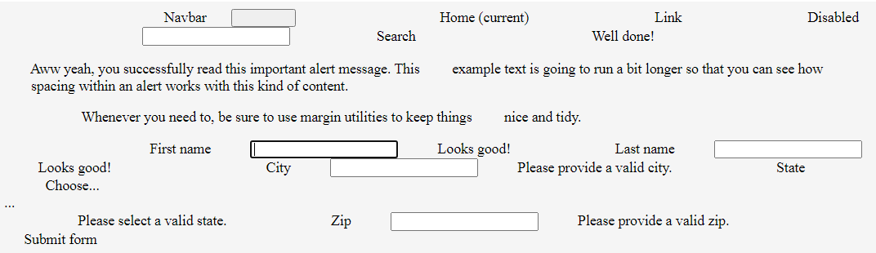

EXPERIMENT 7

7.Creating web pages using PHP.

!DOCTYPE html>

<html lang="en">

  <head>

    <meta charset="UTF-8" />

    <meta http-equiv="X-UA-Compatible" content="IE=edge" />

    <meta name="viewport" content="width=device-width, initial-scale=1.0" />

    <title>Practical 7</title>

    <link rel="stylesheet" href="./Practical-7.css" />

  </head>

  <body>

    <div class="contact-title">

      <h1>Welcome To This Website</h1>

      <h2>We Are Happy To Help You</h2>

    </div>

    <div class="contact-form">

      <form action="Practical-7.php" method="POST" id="contact-form">

        <input

          type="text"

          name="name"

          class="form-control"

          placeholder="Your Name"

          required

        />

        <br />

        <input

          type="email"

          name="email"

          class="form-control"

          placeholder="Your Email"

          required

        />

        <br />

        <textarea

          name="message"

          class="form-control"

          placeholder="Message"

          rows="4"

          required

        ></textarea>

        <br />

        <input type="submit" class="form-control submit" value="Send message" />

      </form>

    </div>

  </body>

</html>

CSS:

body {

  margin: 0;

  padding: 0;

  text-align: center;

  background: rgb(34, 36, 0);

  background: linear-gradient(

    215deg,

    rgba(34, 36, 0, 1) 6%,

    rgba(9, 121, 118, 1) 51%,

    rgba(132, 0, 255, 1) 86%

  );

  background-repeat: no-repeat;

  height: 100%;

  background-attachment: fixed;

  background-position: center;

}

.contact-title {

  margin-top: 100px;

  color: #fff;

  text-transform: uppercase;

  transition: all 4s ease-in-out;

}

.contact-title h1 {

  font-size: 32px;

  line-height: 10px;

}

.contact-title h2 {

  font-size: 16px;

}

form {

  margin-top: 50px;

  transition: all 4s ease-in-out;

}

.form-control {

  width: 600px;

  background: transparent;

  border: none;

  outline: none;

  border-bottom: 1px solid #333;

  color: #fff;

  font-size: 18px;

  margin-bottom: 16px;

}

input {

  height: 45px;

}

form .submit {

  background: #ff5722;

  border-color: transparent;

  color: #fff;

  font-size: 20px;

  font-weight: bold;

  letter-spacing: 2px;

  height: 50px;

  margin-top: 20px;

}

form .submit:hover {

  background-color: #f44;

  cursor: pointer;

}

PHP:

<?php

    $name=$_POST['name'];

    $visitor_email=$_POST['email'];

    $message=$_POST['message'];

[$email_from='guriqbal1921032@gndec.ac.in](mailto:$email_from='guriqbal1921032@gndec.ac.in)';

    $email_subject="New Form Submission";

    $email_body="User Name: $name.\n"."User Email: $visitor_email.\n"."User Message: $message.\n";

[$to="guriqbalsingh@yahoo.com](mailto:$to="guriqbalsingh@yahoo.com)";

    $headers="From: $email_from \r\n";

    $headers .="Reply-To: $visitor_email \r\n";

    mail($to,$email_subject,$email_body,$headers);

    header("Location: Practical-7.html");

?>

**OUTPUT:**

